JOIN OUR ESC VOLUNTEERING!

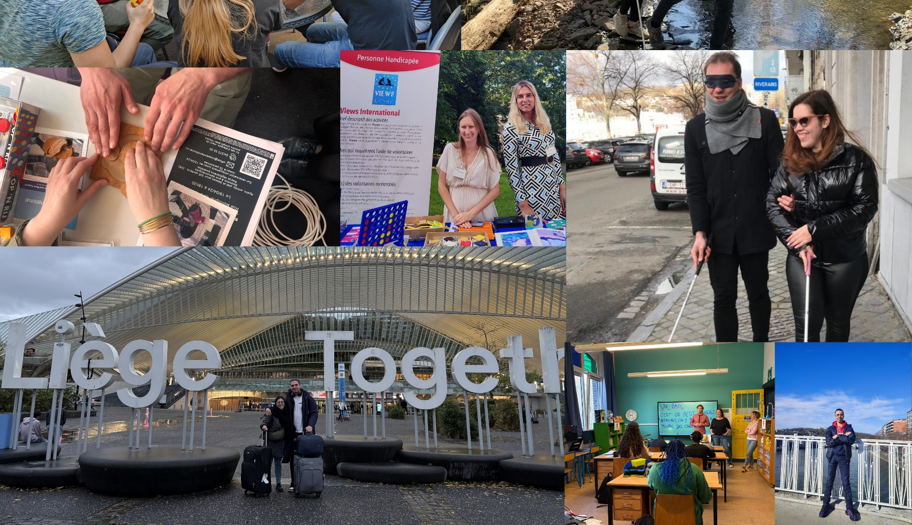
  - Create an impact. Grow your independence. Become part of a community.

Discover European Solidarity Corps volunteering opportunities with VIEWS International and its partners in Liège, Belgium.

office@viewsinternational.eu | www.viewsinternational.eu

BEYOND VOLUNTEERING
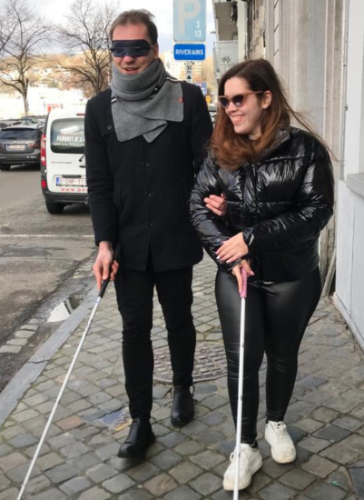
Every volunteering placement has its own activities, responsibilities and working environment. But an ESC experience is shaped by much more than the work you do each day.
Over the course of your project, you'll become part of a local community, meet people from different backgrounds and experience everyday life in Belgium alongside other volunteers, colleagues and local partners. Whether you're supporting young people, contributing to community projects or working in a school, your volunteering experience extends far beyond your host organisation.
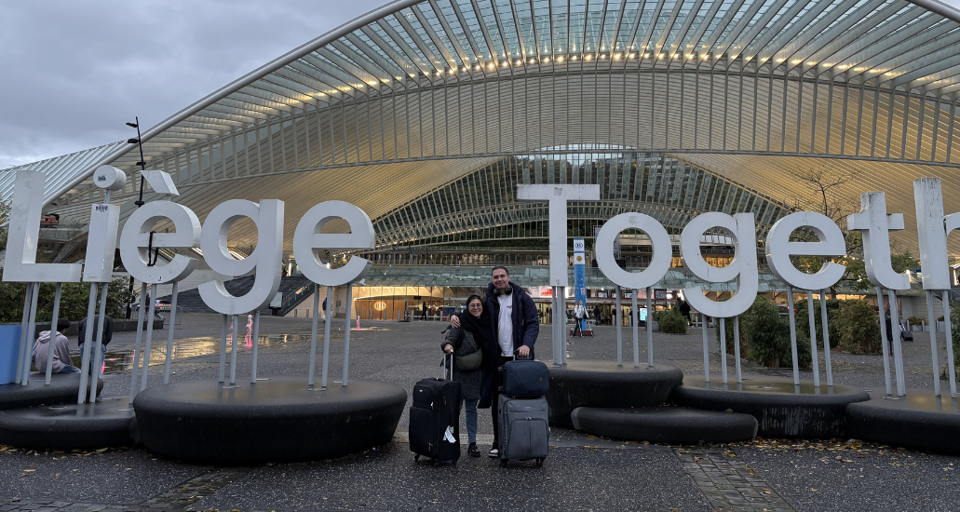
At VIEWS International, we work closely with our local partners to ensure that every volunteer is part of a wider network. Throughout your stay, you'll have opportunities to connect with other volunteers, take part in shared activities and receive ongoing support, whatever placement you choose.
PROJECT 1: VIEWS INTERNATIONAL

About VIEWS International
VIEWS International is a European NGO based in Liège, Belgium, promoting the inclusion, independence and active participation of youth with visual impairments.
Through European projects, local initiatives and international partnerships, we create opportunities for young people to connect, learn and contribute to more inclusive communities across Europe.
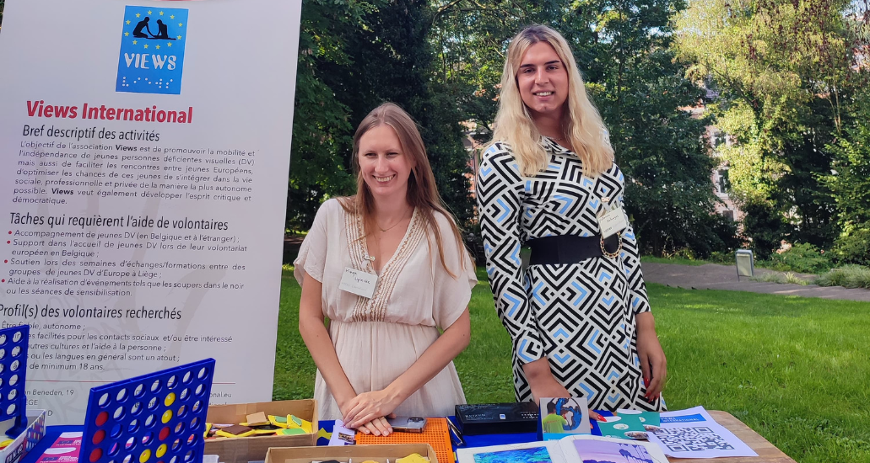
As an ESC volunteer, you will become part of our Executive Office team and support local and international activities alongside visually impaired and sighted colleagues.

What will you do?
Your activities may include:
- supporting the implementation of local and international youth projects;
- helping organise intercultural activities and events;
- contributing to awareness-raising activities on international mobility and visual impairment;
- collaborating with local partners and young people from different backgrounds.

A good fit if you...
This opportunity is particularly suited to someone who enjoys working with people, is curious about international cooperation and would like to contribute to projects with a social impact.
You don't need previous experience. What matters most is your willingness to learn, take initiative and become an active member of the team.
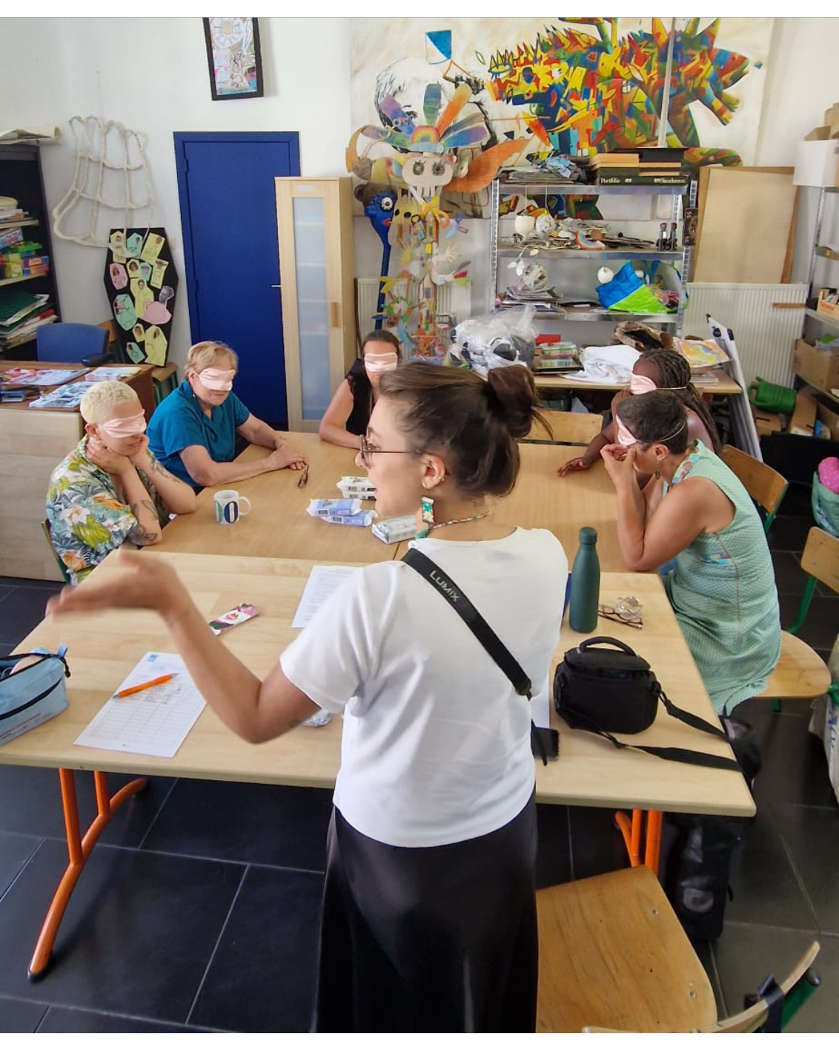


By supporting the Communication & Project Management teams at VIEWS I deeply understood how much work there is behind any project and initiatives to organise accessible activities! I also had the opportunity to be involved into art workshops with my own projects to raise awareness at local level.
- Sofia, ESC volunteer at VIEWS International



PROJECT 2: CSCSM

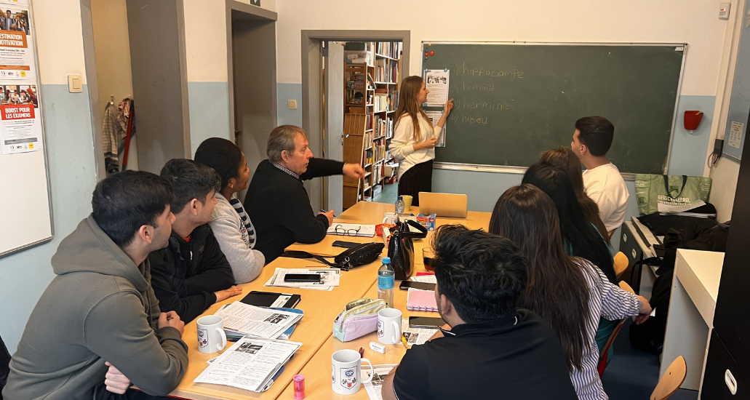
Support young people in one of Liège's most vibrant and multicultural neighbourhoods.

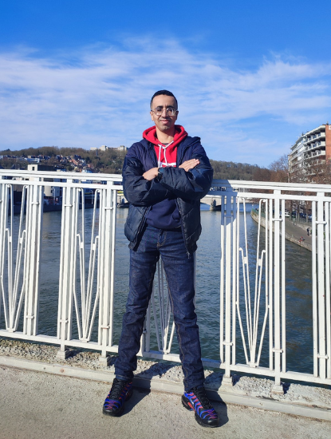
About the host organisations
Your volunteering experience will take place across two organisations working closely together in the Sainte-Marguerite neighbourhood of Liège.
Coordination Socio-Culturelle de Sainte-Marguerite (CSCSM) brings together local organisations working to strengthen community life and promote social inclusion. One of its member organisations is La Baraka, a youth centre that offers educational, cultural and community activities for children, teenagers and families.
As an ESC volunteer, you'll become part of this local network, supporting projects that encourage participation, intercultural dialogue and equal opportunities for young people.
What will you do?
Your activities may include:
- supporting French as a Foreign Language classes for non-francophone teenagers;
- helping organise workshops and activities together with local associations;
- facilitating discussions and non-formal learning activities with young people;
- contributing to the production of the community newspaper Salut Maurice!
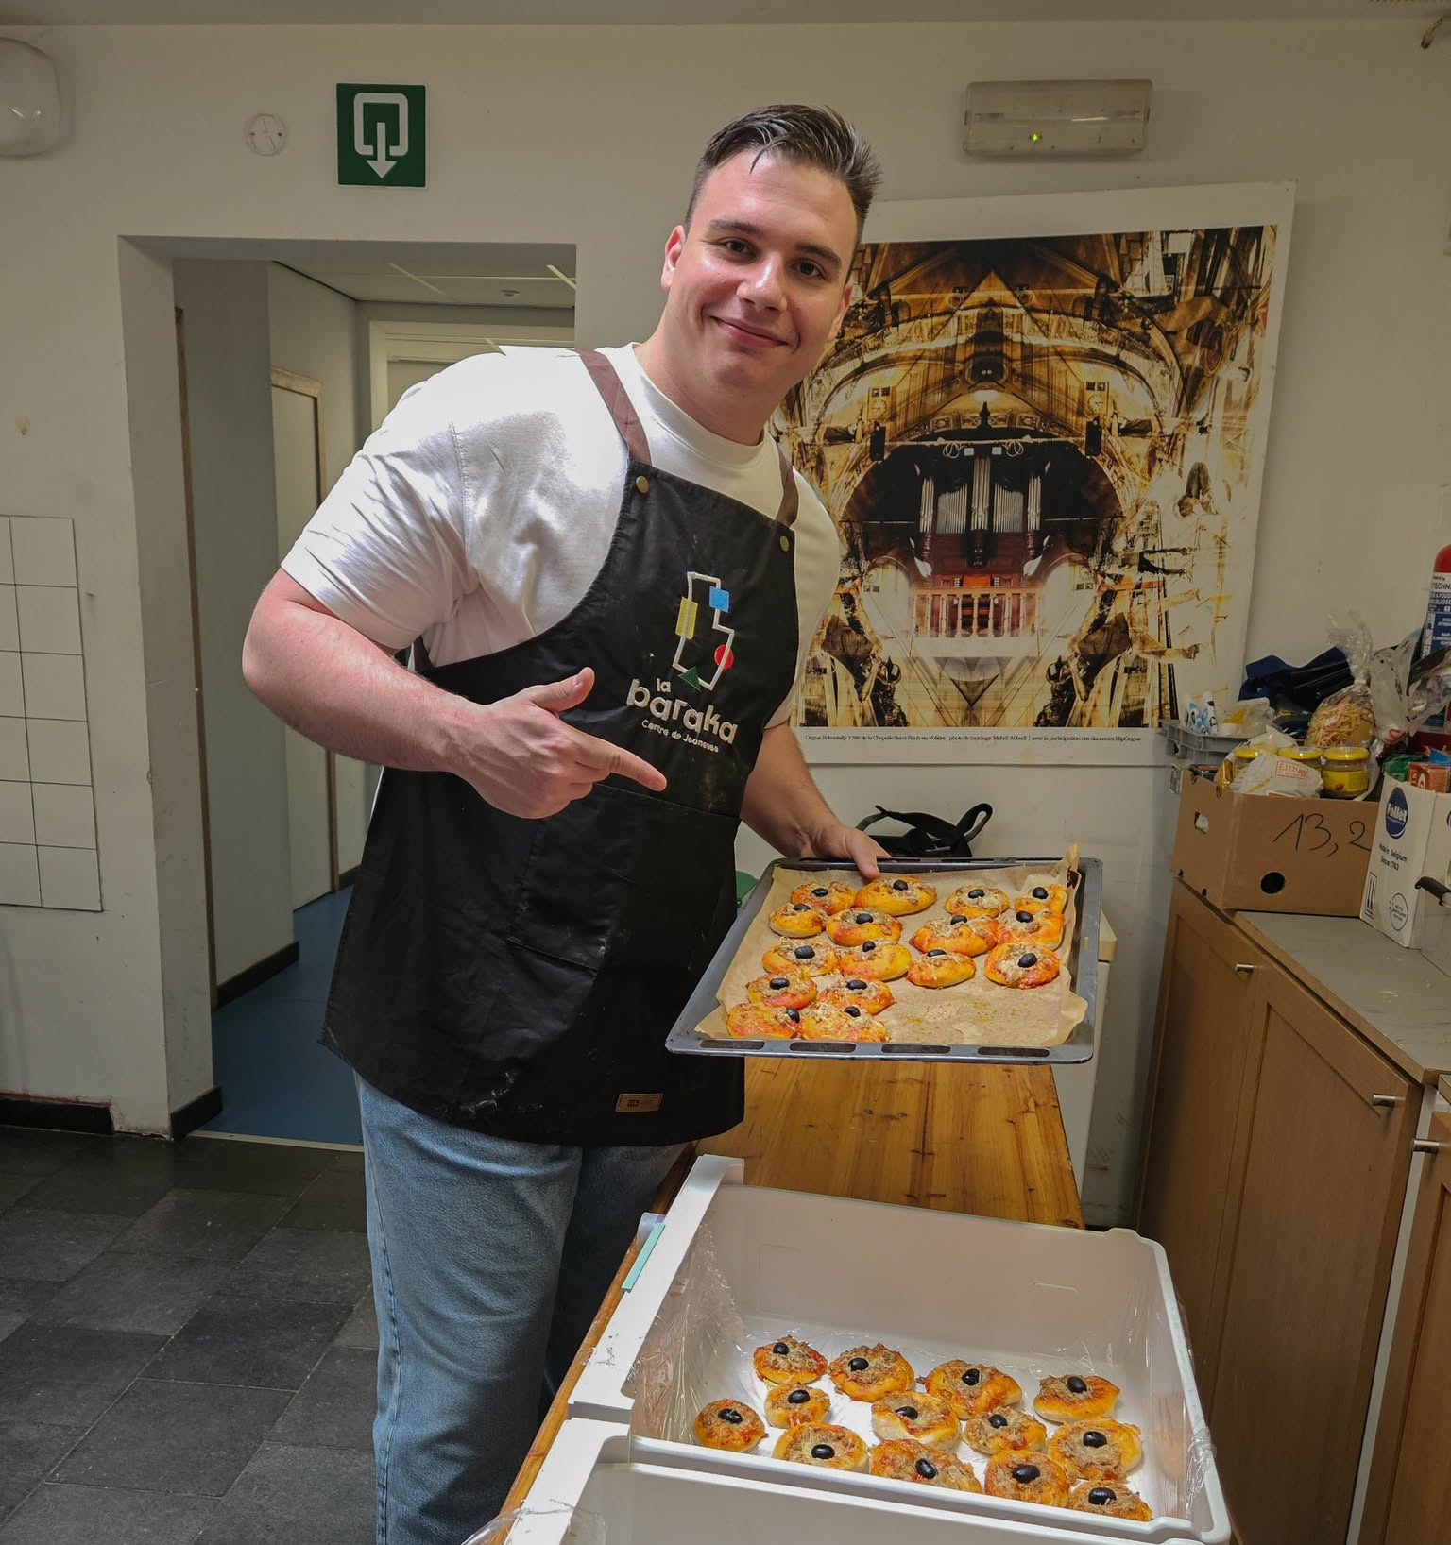
Every week is different, giving you the opportunity to work with people of different ages and backgrounds while experiencing community life from the inside.

A good fit if you...
This opportunity is ideal if you enjoy working directly with people and would like to become involved in community-based projects.
You don't need to be a teacher or youth worker. Curiosity, openness, good listening skills and a willingness to contribute are much more important than previous experience.
It's exciting to see how small changes can make learning more engaging and accessible!
- Silviu, former ESC volunteer at La Baraka and CSCSM


PROJECT 3: IRHOV 1 & 2

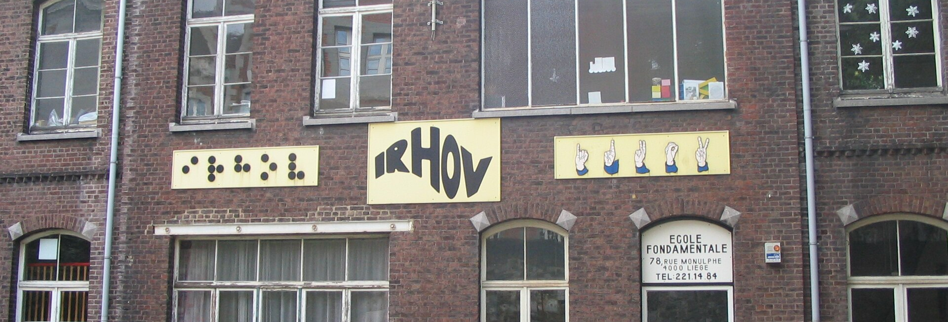
Support children and young people with visual and hearing impairments in their everyday school life.

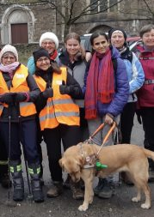
About IRHOV
The Institut Royal pour les Handicapés de l'Ouïe et de la Vue (IRHOV) is a specialised school in Liège supporting children and young people aged 3 to 21 with visual and hearing impairments.
Education at IRHOV extends beyond the classroom. Alongside academic learning, students take part in sports, cultural activities and projects that encourage participation, independence and inclusion. As an ESC volunteer, you'll become part of the school community, working alongside teachers and educators to support students in educational and extracurricular activities.

What will you do?
Throughout your volunteering experience, you'll contribute to the daily life of the school by supporting students, educators and activity leaders.
Your activities may include:
- taking part in extracurricular activities while supporting students in the use of assistive technology;
- helping connect students, educators and activity leaders during sports days, theatre workshops and other activities;
- encouraging interaction and exchange between visually impaired and sighted young people;
- supporting Braille learning and practice;
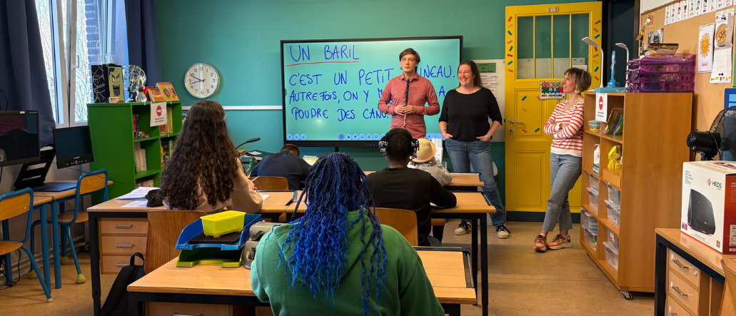
- helping students develop their keyboard and computer skills.

A good fit if you...
This placement is particularly suited to volunteers who already have experience navigating daily life with a visual impairment and feel confident using the tools that support independence.
Because you'll work directly with children and young people, you should also:
- be comfortable reading and writing Braille;
- use assistive technology confidently in everyday situations;
- have a beginner level of French (A2 or above), as you'll communicate daily with students and school staff;
- enjoy working in a structured educational environment and supporting children in their everyday activities.
Previous teaching experience is not required. However, confidence in your own independent living skills and a willingness to share that experience with younger students will help you make the most of this opportunity.
I got to meet people from different backgrounds and gain new perspectives on myself and my time here.
— Jasper, former ESC volunteer at IRHOV
ACCESSIBILITY AND SUPPORT

Supporting your independence
Every volunteer arrives in Belgium with different experiences, routines and specific requirements
That's why accessibility at VIEWS International is never one-size-fits-all. From the moment you're selected until the end of your volunteering experience, we'll work together to identify the support and accommodations that best match your individual needs.
Our goal is simple: to help you become confident in your new environment, develop your independence and make the most of your ESC experience.

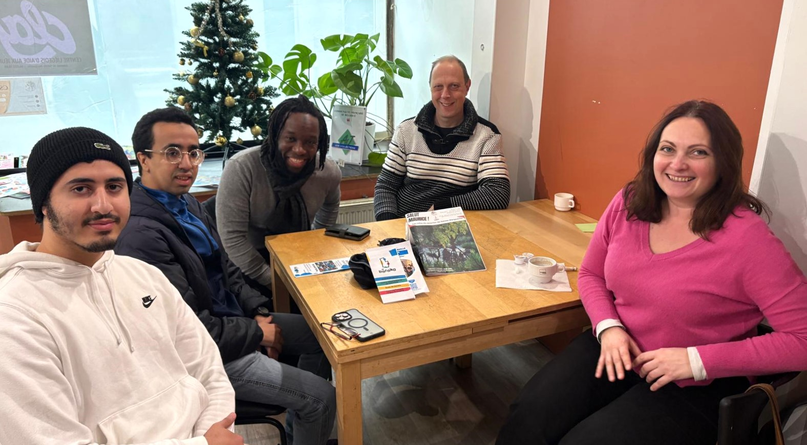
Before you arrive
Before moving to Belgium, through an Advanced Planning Visit (APV), you will visit your future accommodation, discover your host organisation and explore the city of Liège. You will also meet the people who will support you throughout your volunteering experience and discuss with them your needs and expectations.
Before your arrival, you will also receive our Volunteer Guide, designed to help you prepare for everyday life in Belgium.

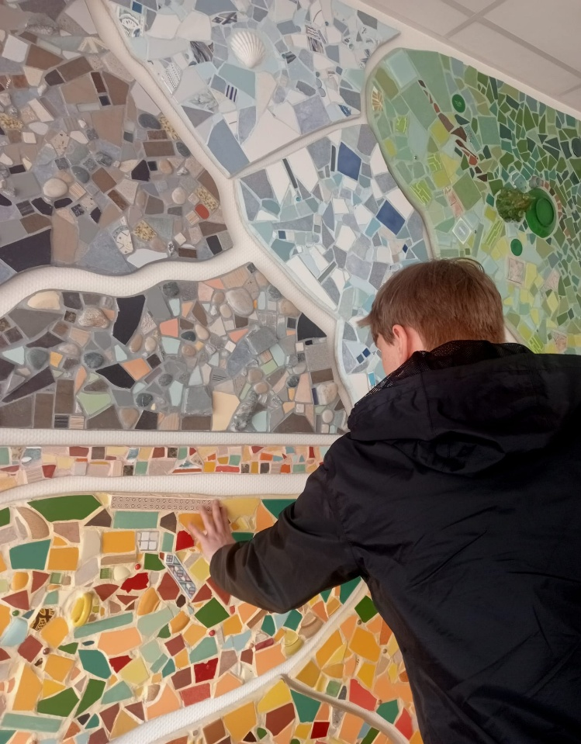
Your first weeks
Your first weeks are dedicated to becoming familiar with your new surroundings before starting your volunteering activities.
Your introduction programme may include:
- orientation and mobility training;
- daily living skills;
- one-to-one French classes;
- Braille or large-print adaptations;
- getting familiar with your workplace and daily routines.
The aim is not only to help you settle in, but to give you the confidence to navigate your new environment independently.

Reinforced mentorship
Throughout your project, you'll be supported by a dedicated mentor as well as the VIEWS International team and your host organisation.
Your mentor is there to listen, answer questions and help you reflect on your experience as it develops. Regular follow-up meetings also provide opportunities to discuss your progress, review your learning objectives and identify any additional support you may need along the way.

Throughout your stay
As your confidence grows, so does your independence. Support remains available throughout your volunteering experience, adapting to your evolving needs while encouraging you to take ownership of your everyday life, your work and your personal development.

Financial support
As an ESC volunteer, you'll receive:
- accessible accommodation;
- food allowance;
- pocket money;
- local transport;
- European Solidarity Corps insurance.


Follow us on social media! Facebook | Instagram
Funded by the European Union. Views and opinions expressed are however those of the author(s) only and do not necessarily reflect those of the European Union or the granting authority. Neither the European Union nor the granting authority can be held responsible for them.
VIEWS International aisbl
19-001 Quai Van Beneden, 4020 Liège, Belgium
office@viewsinternational.eu | www.viewsinternational.eu

INTERESTED? VISIT OUR WEBSITE OR CONTACT US!

